 **SC-114 Fundamentals of Programming**

**Title:**

Assignment 1

**Submitted by:**

|  |  |
| --- | --- |
| Name: | Ali Zeeshan Rauf |
| Section: | Me-15 (C) |
| Roll No: | 467537 |

**Submitted to:**

Dr. Talha Shahid

**Date of submission:**

12 October 2023

**Lab manual 2**

**Lab tasks**

1. Write a program that determines if a person is eligible to vote based on their age (e.g., 18 Years or older) using logical operators.

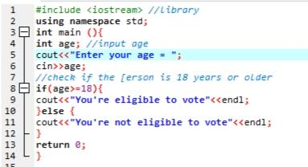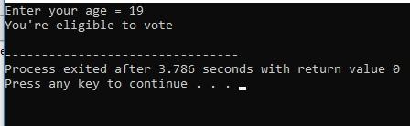

1. Write a program that takes an integer as input and checks if it falls within the range [10, 30] Using logical operators.

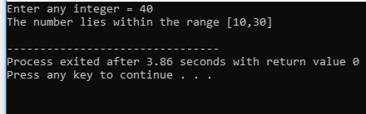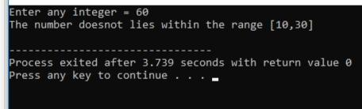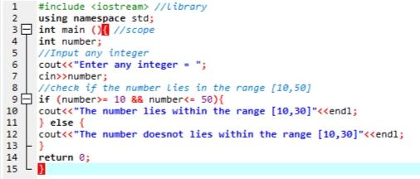

1. Write a C++ program to compare two integers and find the maximum value.

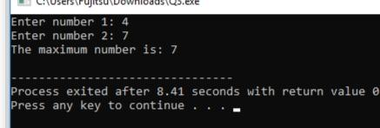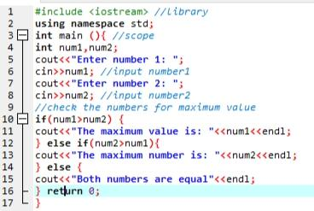

1. Write a C++ program to calculate the average of three exam scores and determine if it’s Above a passing grade (e.g., average >= 60).

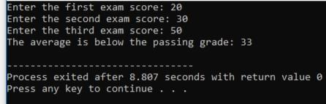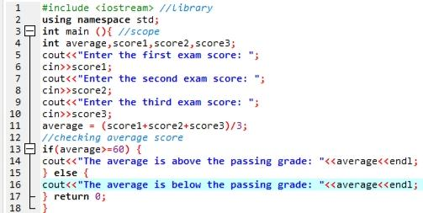

**Hometasks**

1. Create a program that takes a student’s score as input and assigns a grade based on Predefined criteria using logical operators (e.g., A, B, C, D, F).

A-Grade: 90-100 Marks

B-Grade: 75-90 Marks

C-Grade: 60-75 Marks

D-Grade: 45-60 Marks

F-Grade: 0-45 Marks

1. 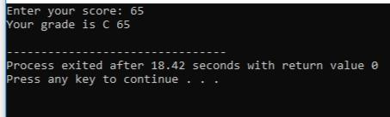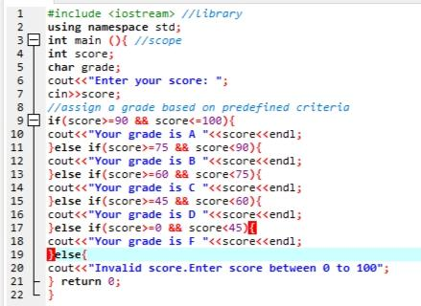Write a program that takes an integer as input and determines if it is both even and divisible by 5.

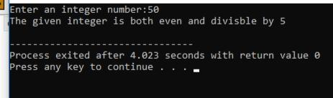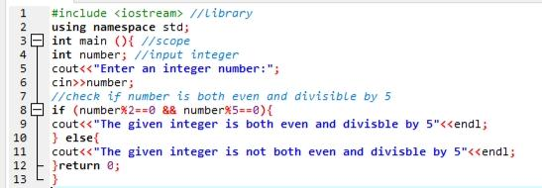

1. Create a C++ program that determines if a student is eligible for a scholarship based on their GPA (must have GPA >= 3.5) and attendance (must have attended at least 80% of classes).

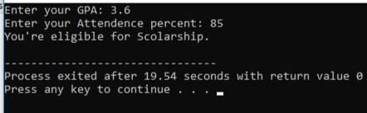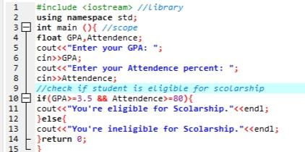

1. Create a C++ program that checks if a user-provided year is a leap year.

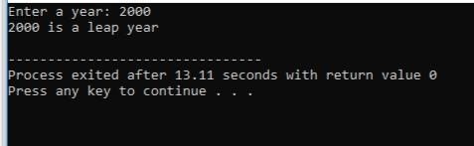

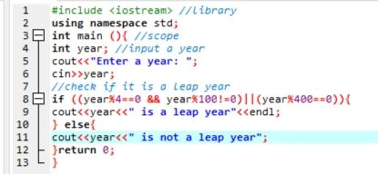

1. Write a program that checks if a given character is a vowel (a, e, i, o, u) or a consonant using logical operators.

